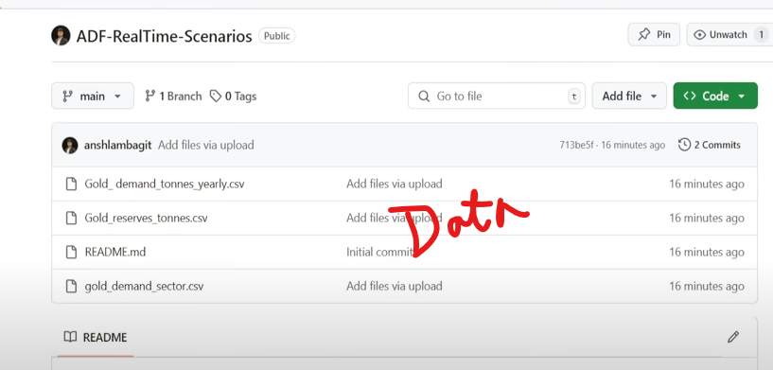 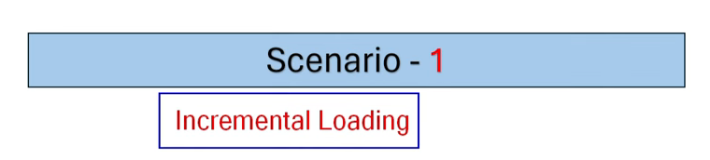 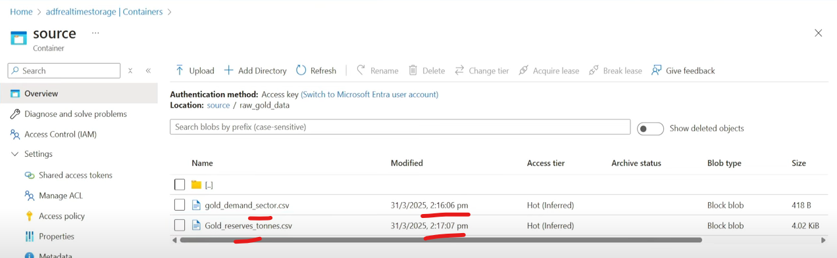  
Create a LS and a DS(make it parameterized so that it can be used for both source and sink)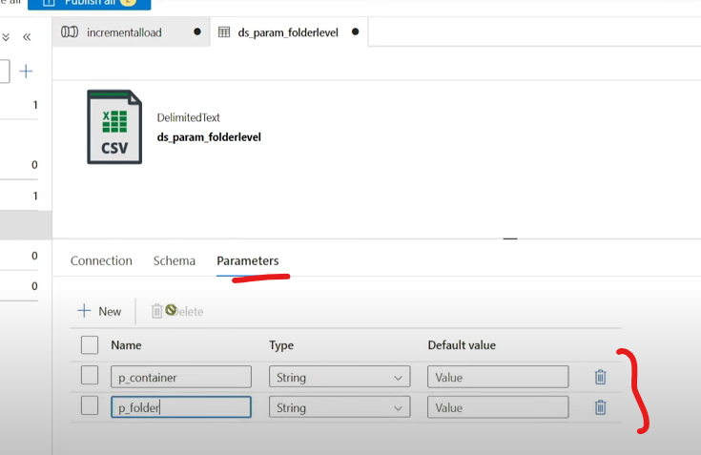

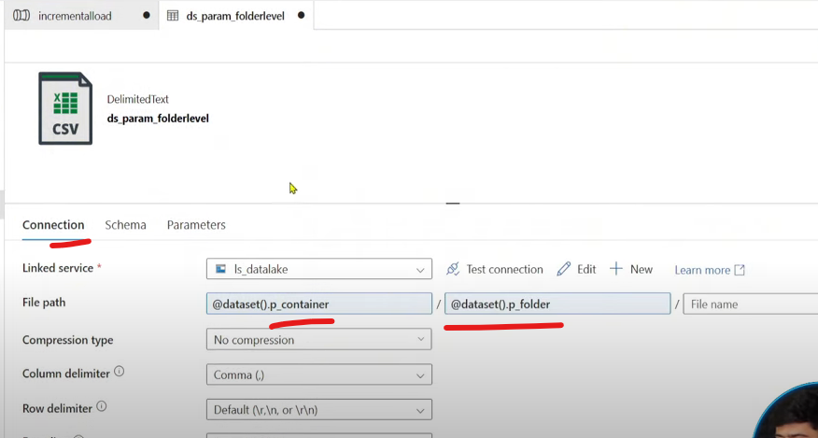   
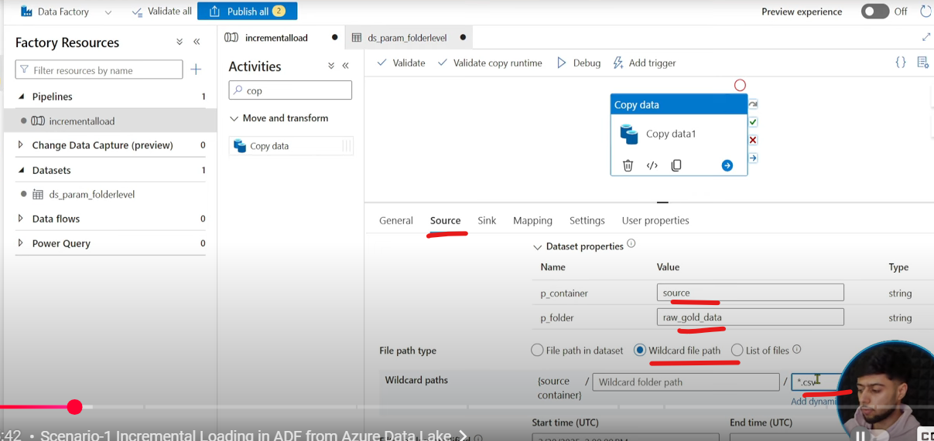  
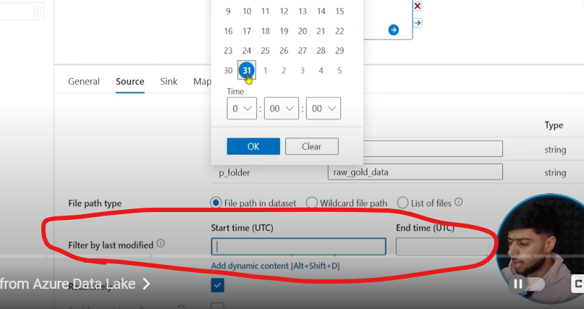  
Have to play around with last modified filter  
  
Now lets start designing the pipeline  
Use a Get Metadata activity to retrive all the files  
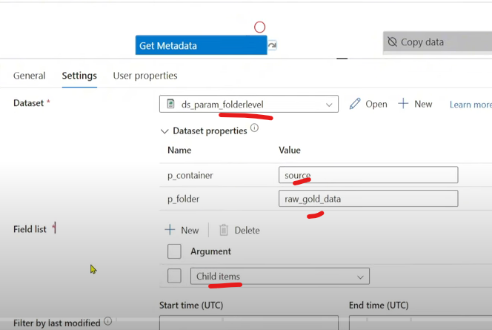   
Loop through all the childitems  
  
Use a Get Metadata activity inside For-Each to retrieve the last modified date of each files  
Create a new dataset  
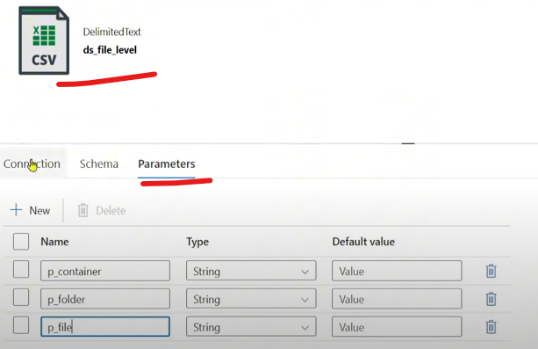 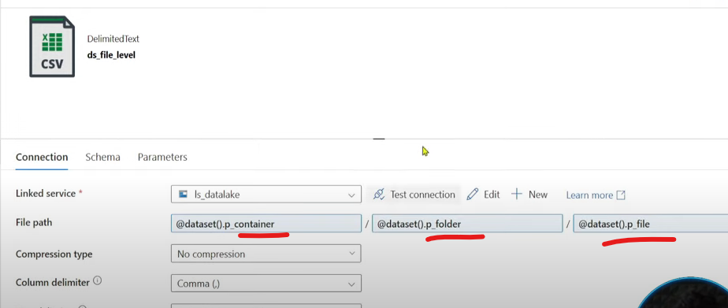  
We need to save the last modified date in a variable so that we can compare the dates.  
 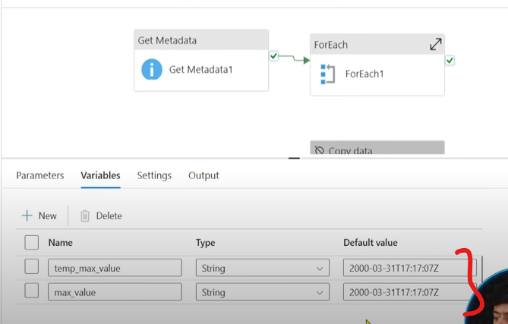  
If output of last modified is greater than temp_max_value then replace value of max_value with last modified date, if not keep it as is.  
  
 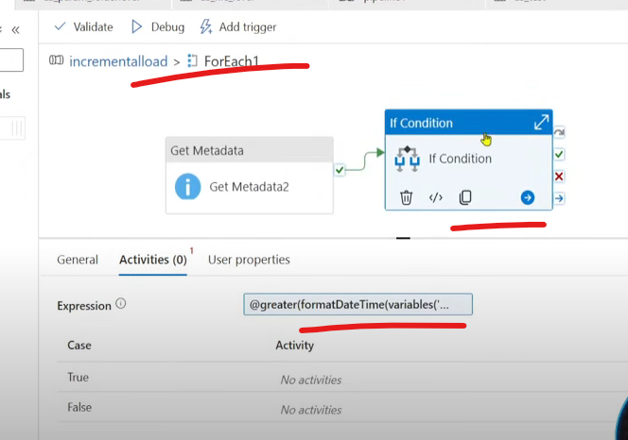  
You can use greater also, just swap the order  
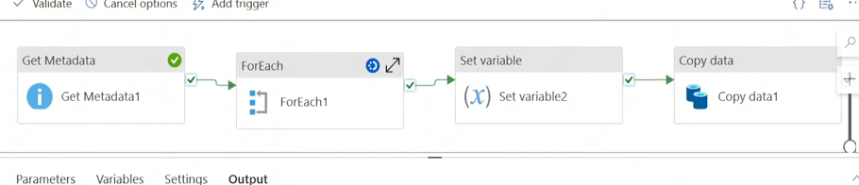 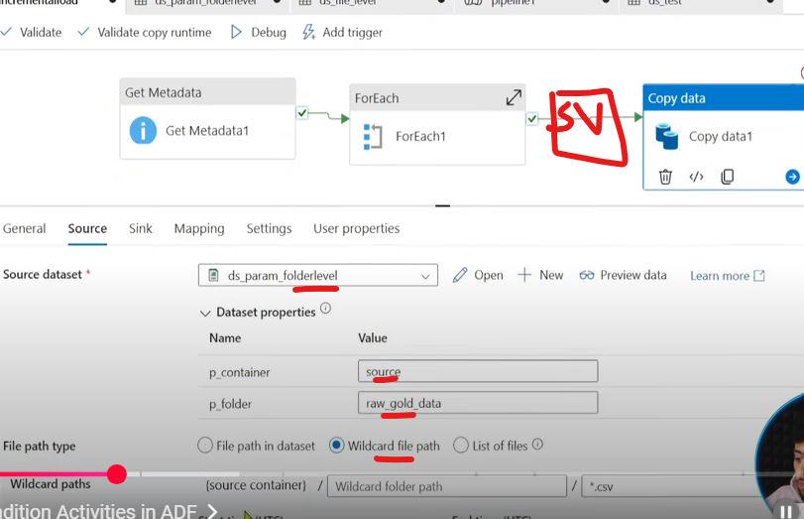

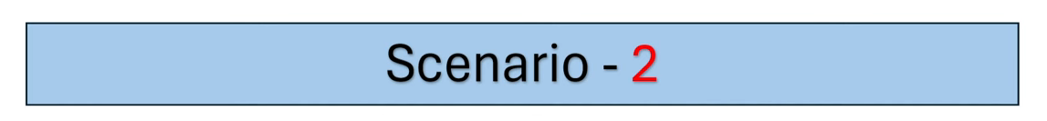  
Copy only those files which are not available in the destination (previously done) 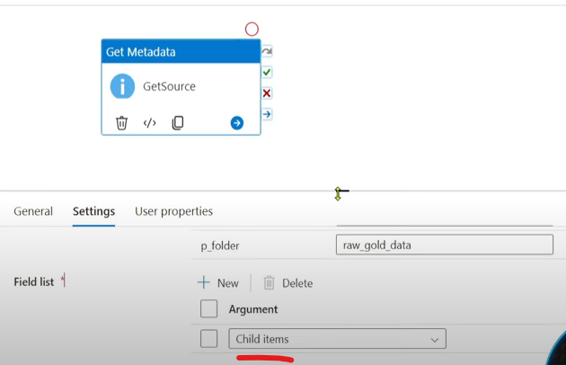  
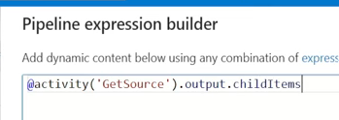 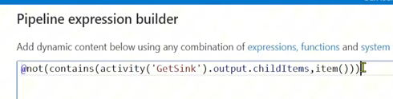  
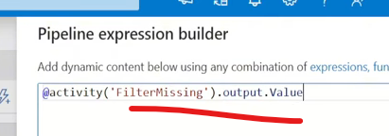   
  
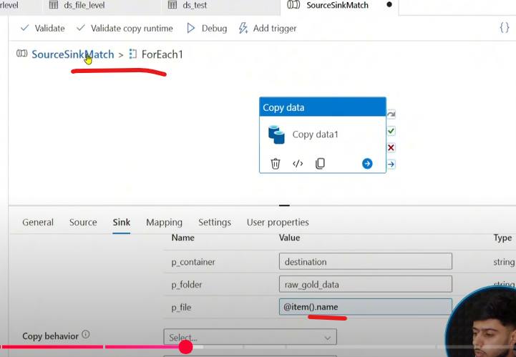

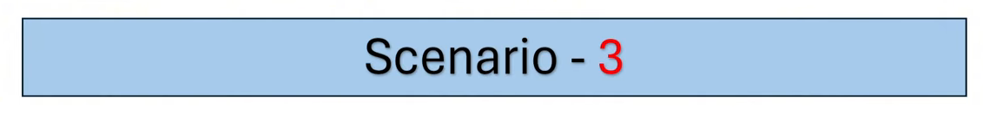  
Copy only those files which are submitted within 24 hours  
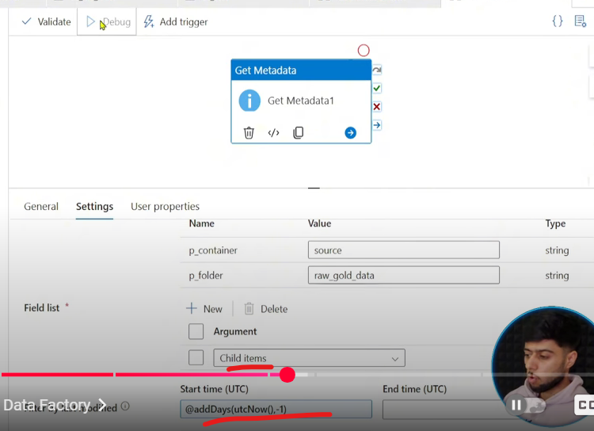   
  
Complete the flow  
Now lets say we have to copy the files which are older than 7 days, same method, instead of Start time provide End time 🡪 @addDays(utcNow(),-7)  
  
M1: same as last approach, provide end time in Get Metadata and inside For-Each provide Delete activity  
M2:  
Create a pipeline parameter to pass number of days dynamically  
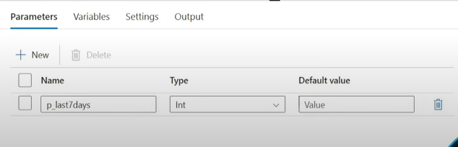  
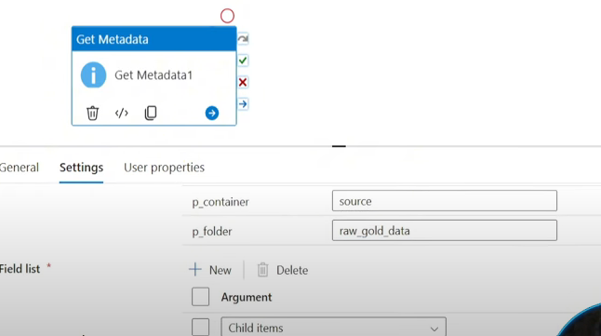 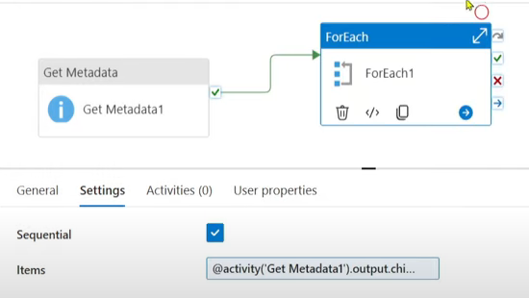  
Pass -7 in parameter as we havent considered minus in the code

  
Count the number of files in a container

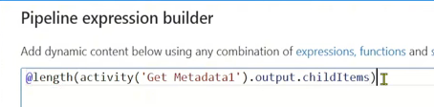

  
Dynamic Schema Mapping  
Refer previous documentation : you can see we have passed the parameters as Object  
  
Extra: You can also pass as String  
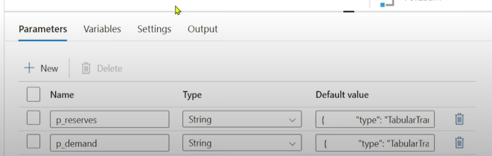  
  
Pass it like a string by encapsulating within a string  
  
  
M2: Remove the encapsulated string  
